|  |  |  |  |  |  |
| --- | --- | --- | --- | --- | --- |
| **Features** | **EXPRESS** | **BASIC** | **STANDARD** | **PROFESSIONAL** | **BUSINESS** |
| Multiunit | - |  |  |  |  |
| production | - |  |  |  |  |
| Multi store | - | - |  |  |  |
| Department | - | - |  |  |  |
| Multi branch | - | - | - |  |  |
| Multi currency | - | - | - |  |  |

**SOFTWARE DIFFERENCES**

**MULTIUNIT**

Enable to some items in multiunit

EX: CHOCLATE->PCS,BOX,PACKET

Tools->Application settings->Application features

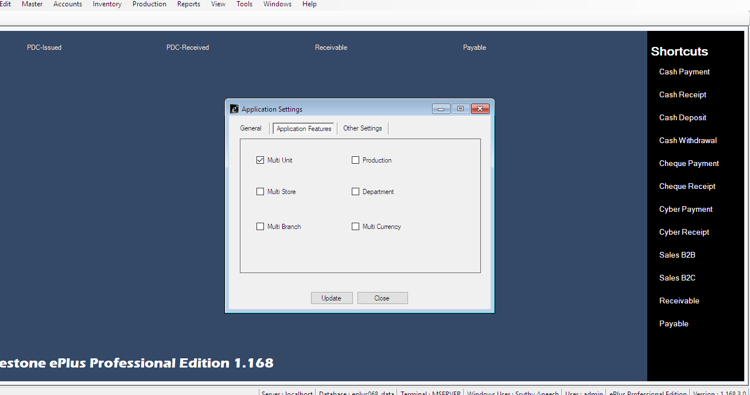

Mater->Item-> Select Item ->select unit->Enter item multi units->save

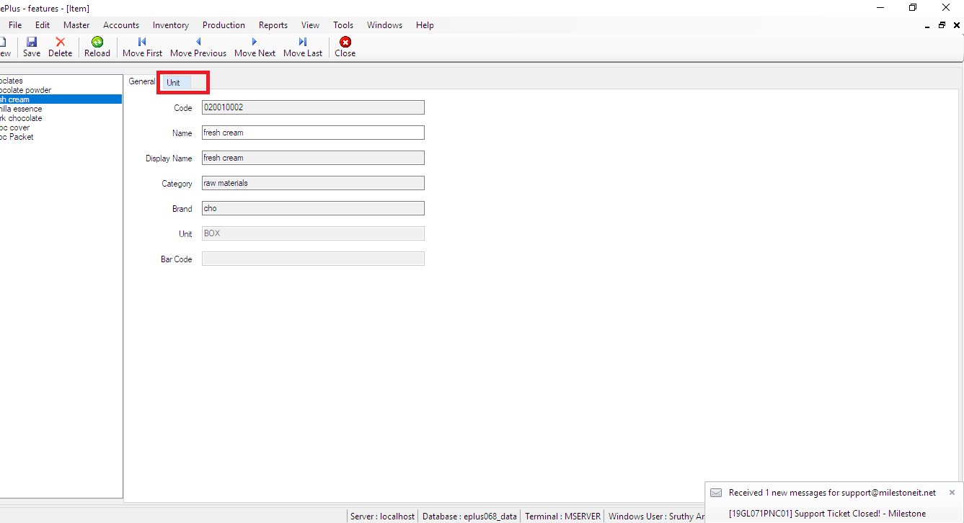

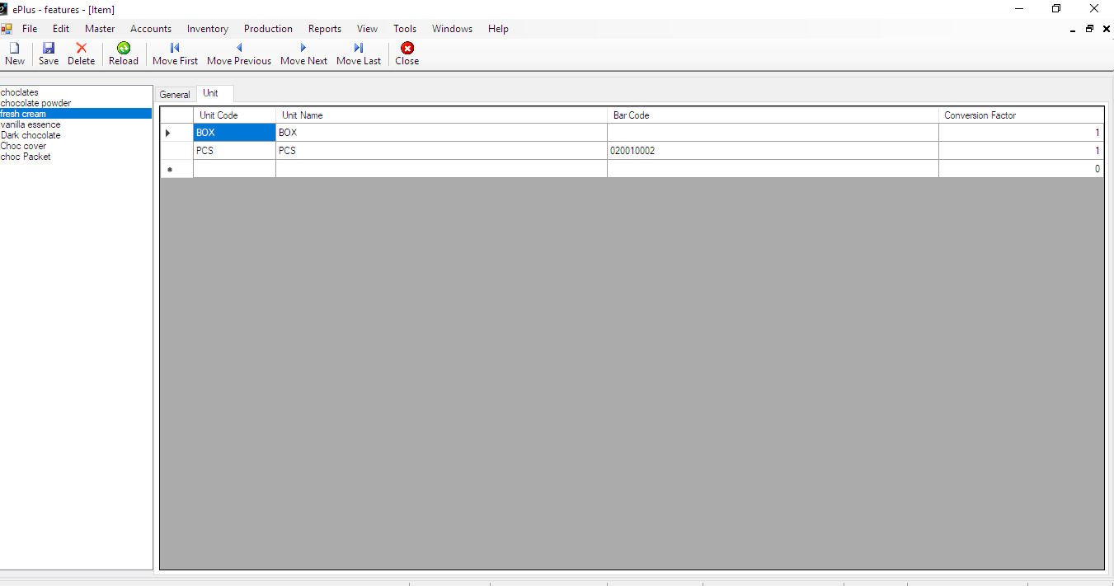

**PRODUCTION**

**Production** is a process of combining various material inputs and immaterial inputs

Tools->Application settings->Application features->Enable Production->save

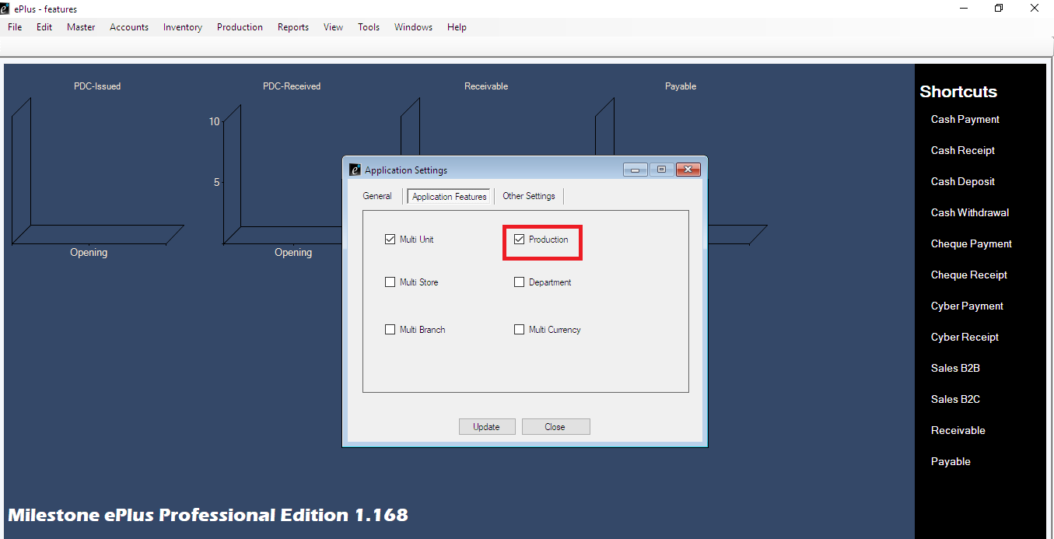

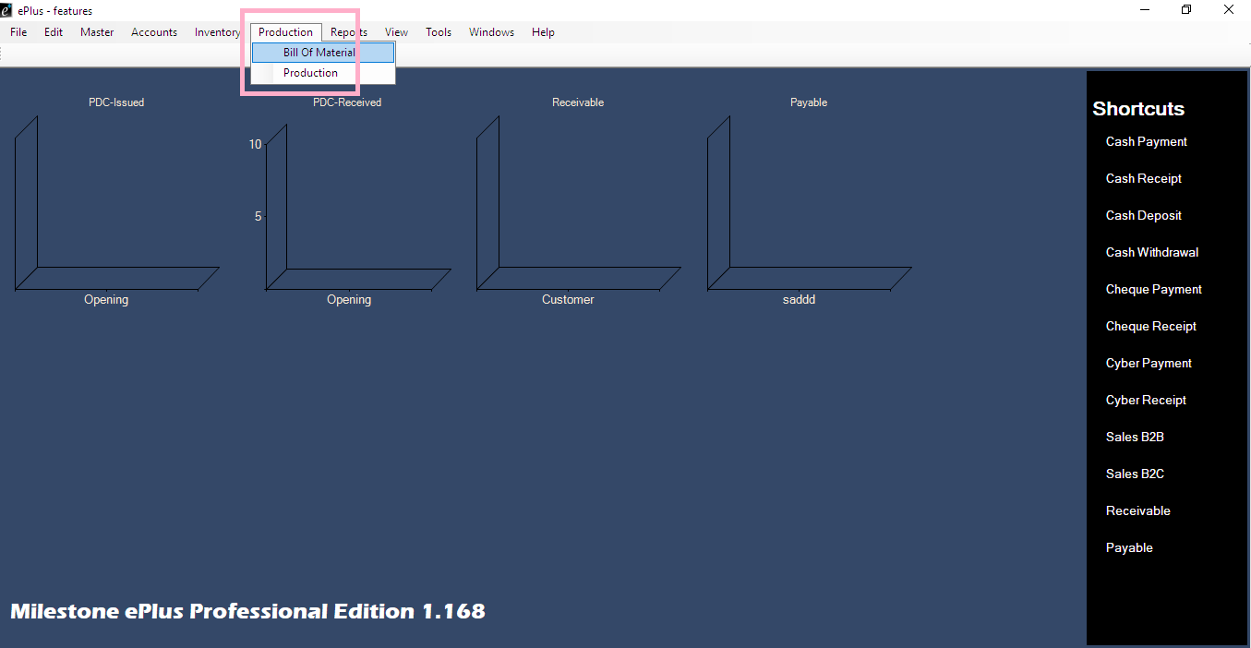

Need more settings in production

Tools->settings->function settings->Production Transactions rightclick->details->Active

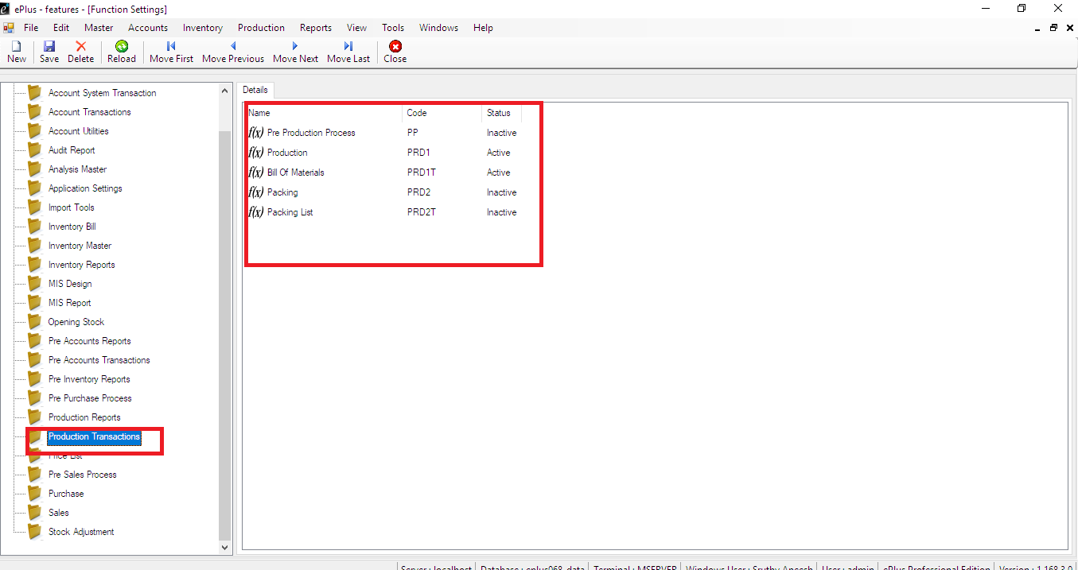

Create category

Master->category->Enter category->save

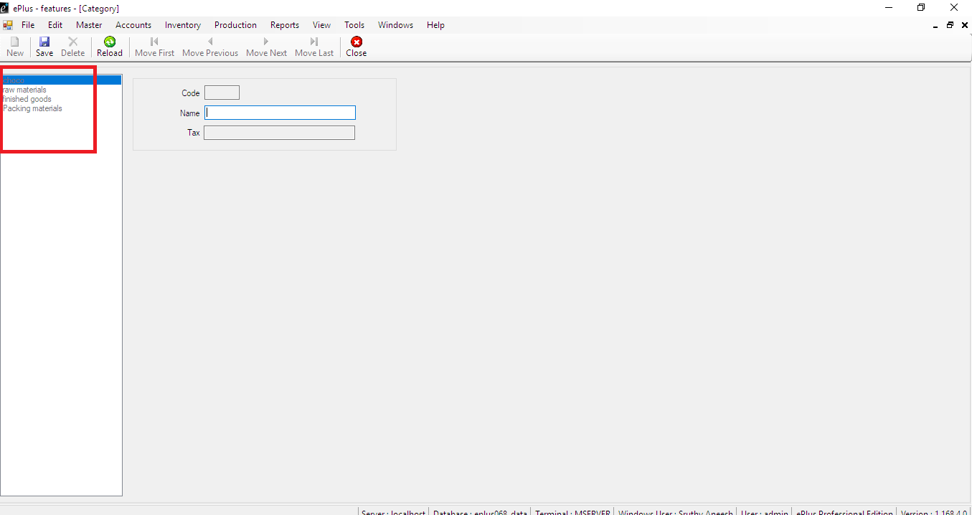

Create items

Master->items->Enter raw materials,finished goods,packing materials

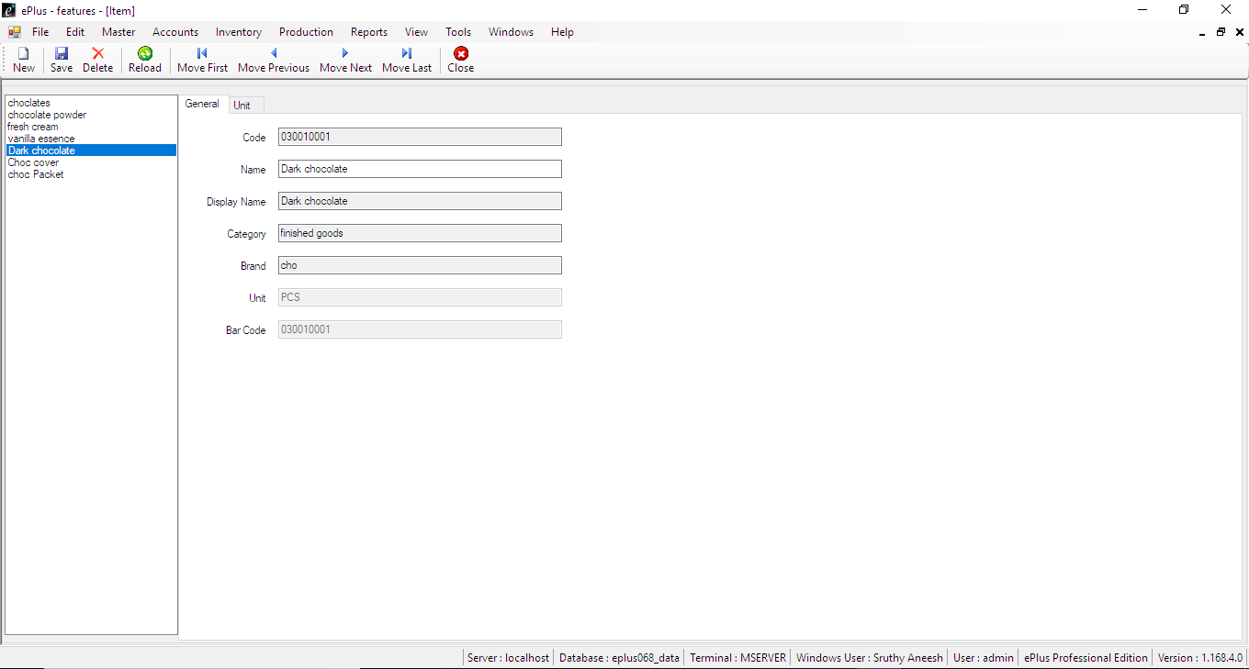

Purchase raw materials

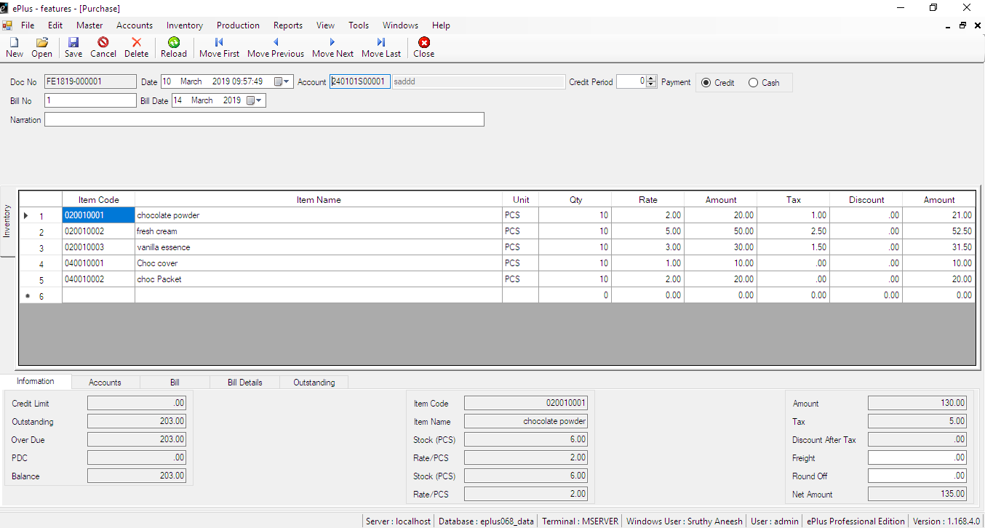

Select the item for finished goods raw materials

Production->Bill of Materials->select the items->save

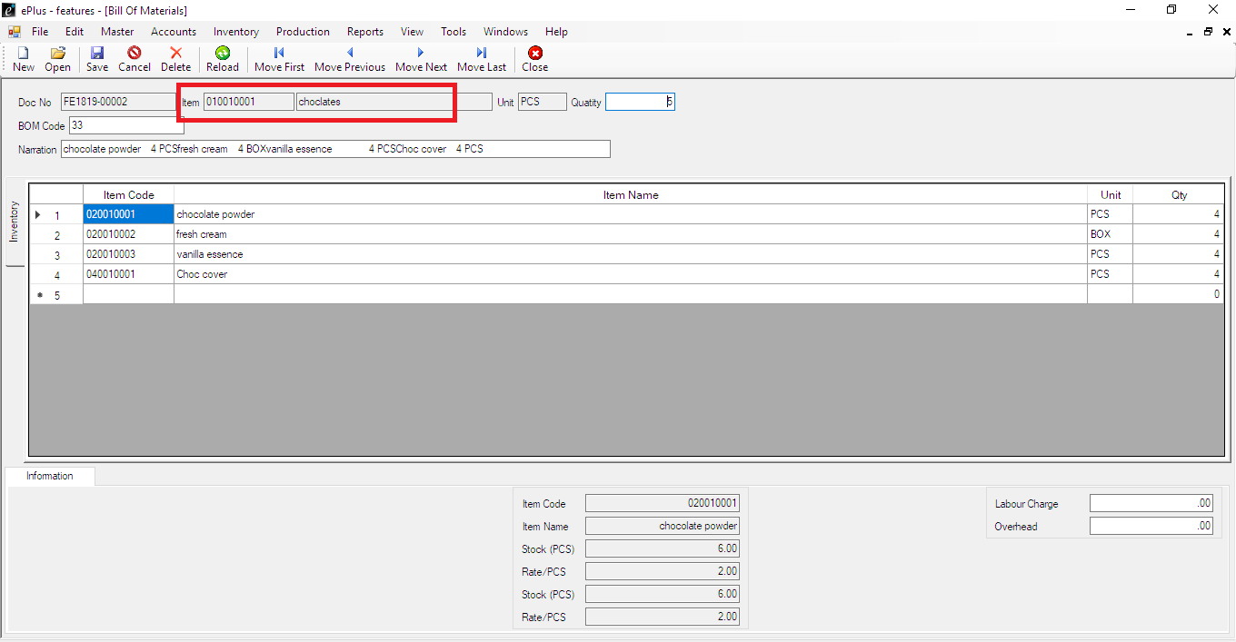

Production->production select

Select item code->enter->To call the finished goods

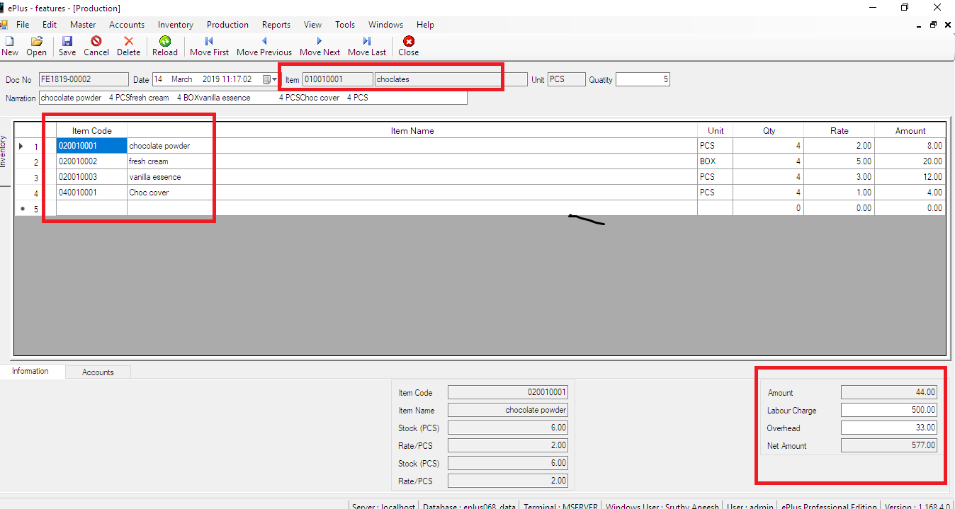

**MULTI STORE**

Tools->Application settings select->Application Features->Multi store->update

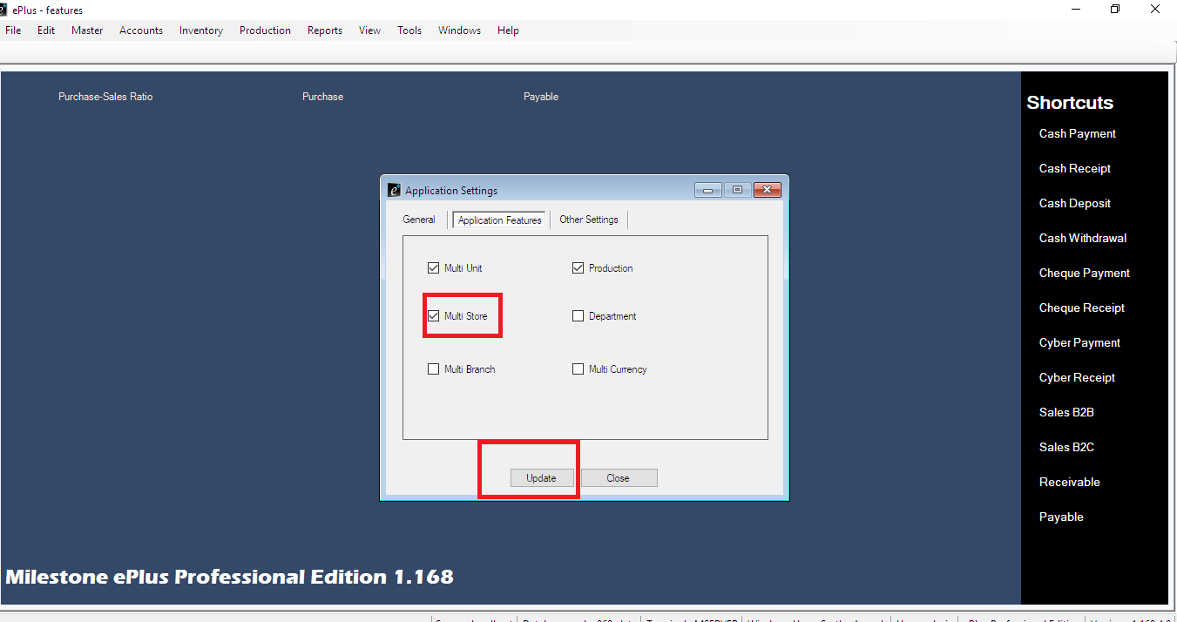

To create store

Master->select store->create store->save

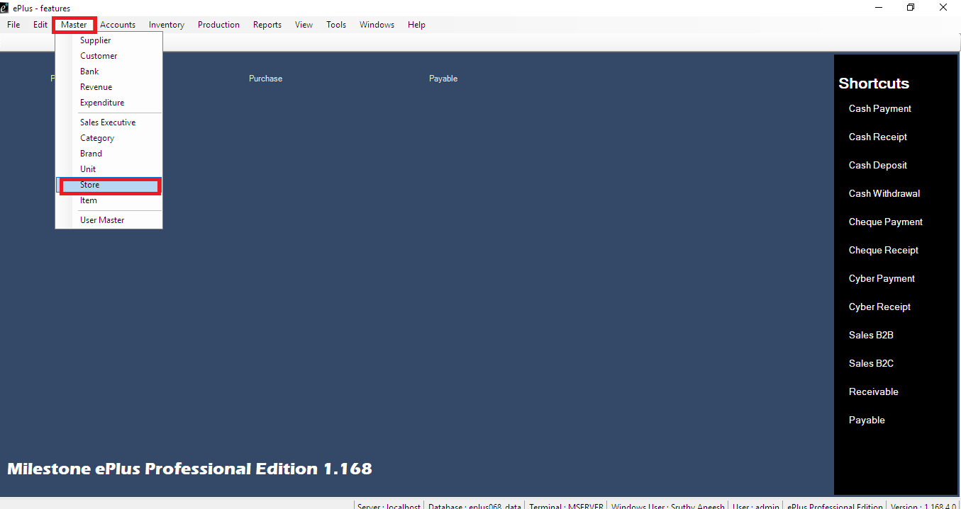

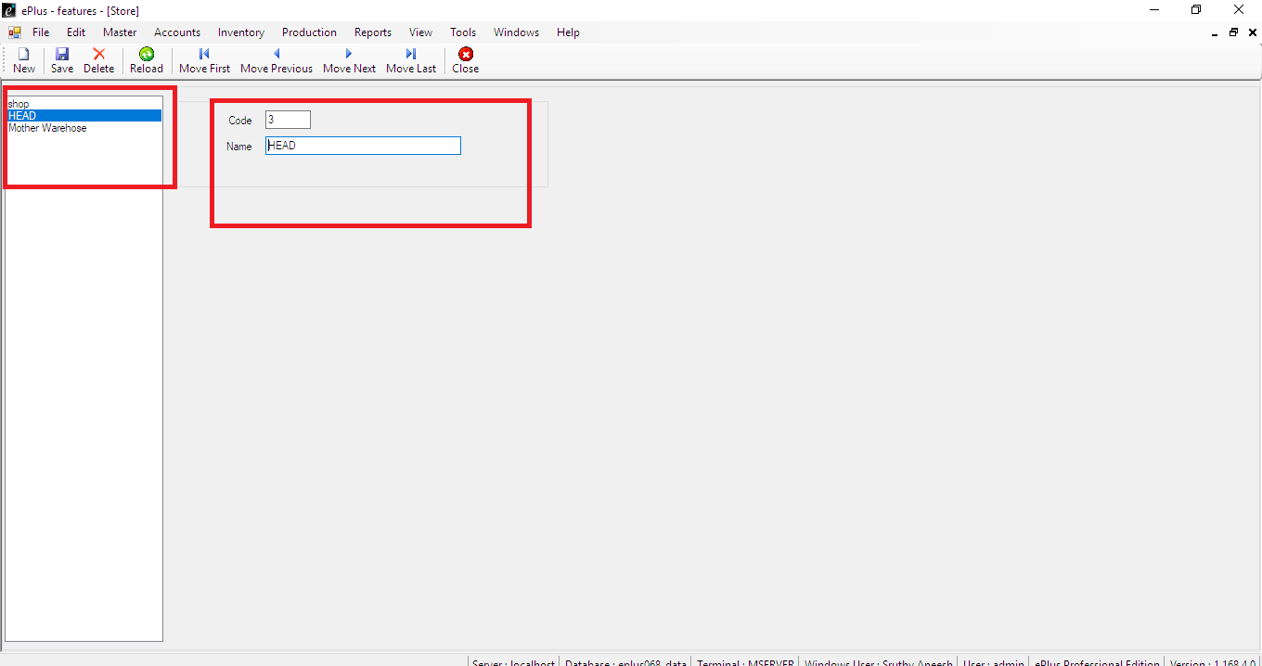

Inventory->purchase->show store->select store

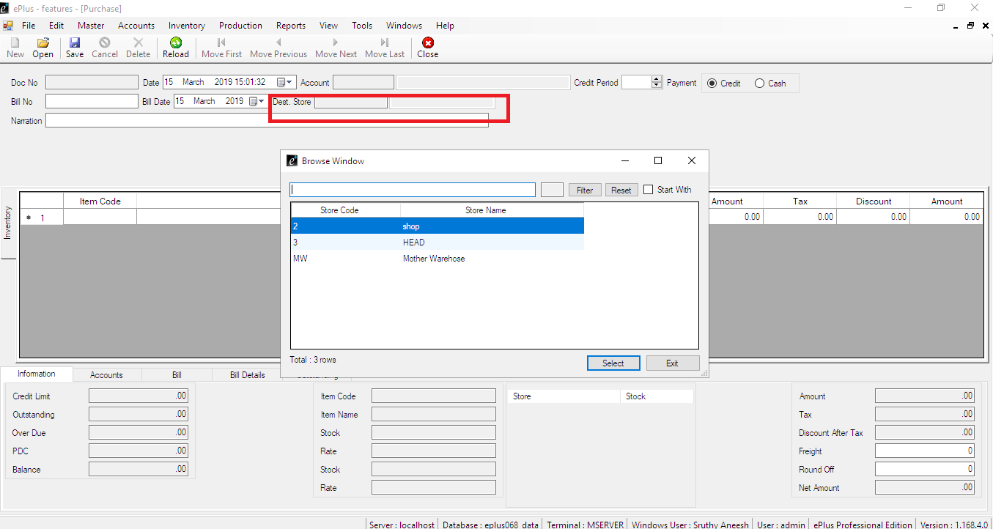

Inventory->sale->show store->select store

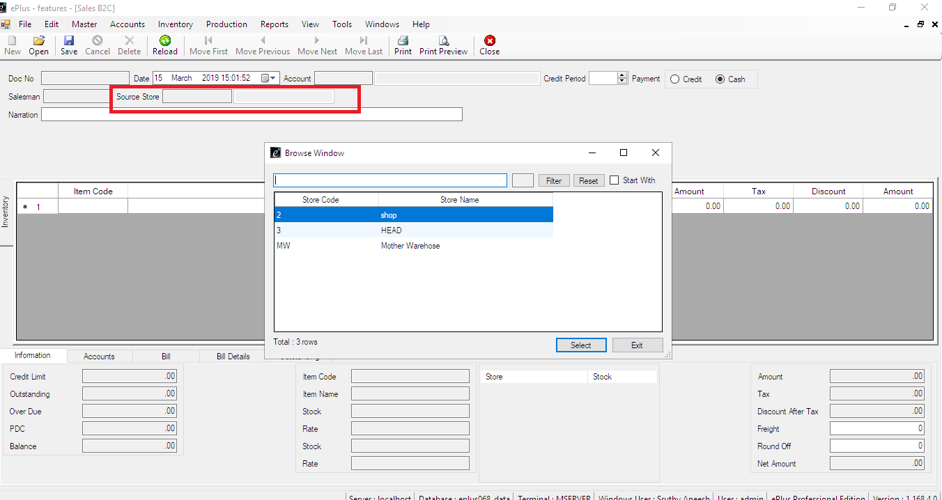

DEPARTMENT

Tools->Application settings->Application features->Select Department->update

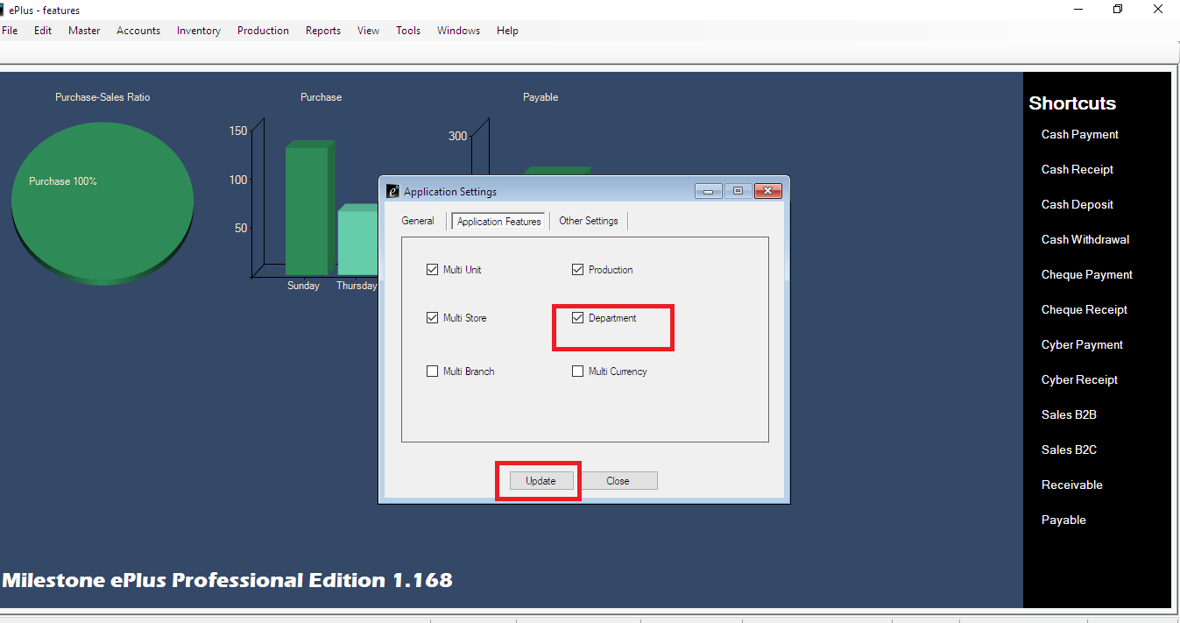

To give privilege on department

Tools->settings-> select privilege settings

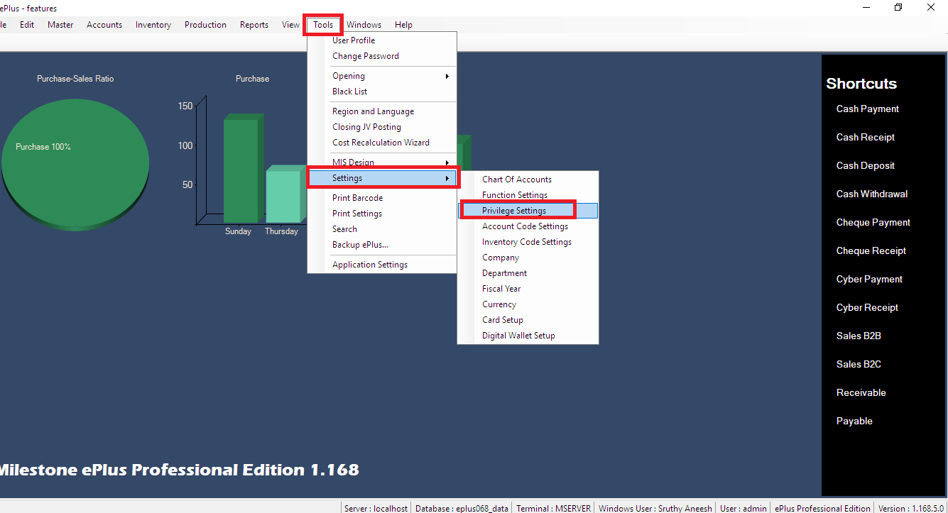

Give privilege

Application settings->department->right click on right side ->select user->select create and modify->save

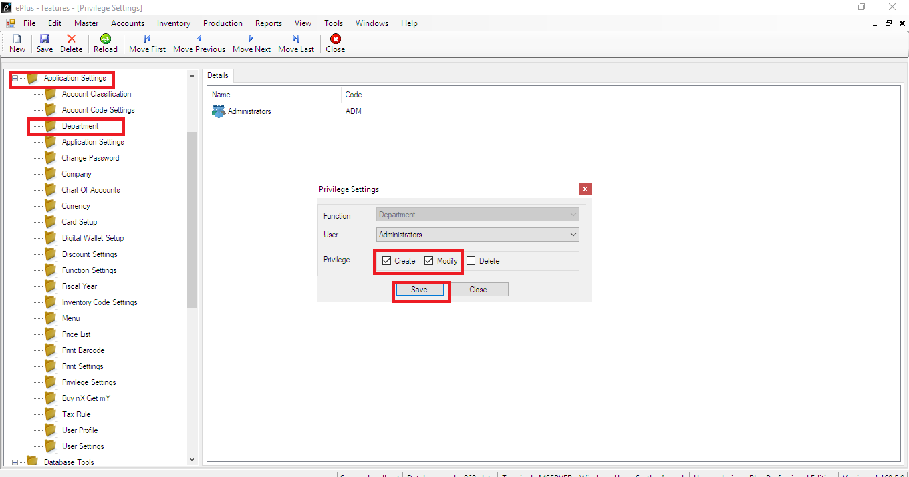

Tools->settings-> select departement

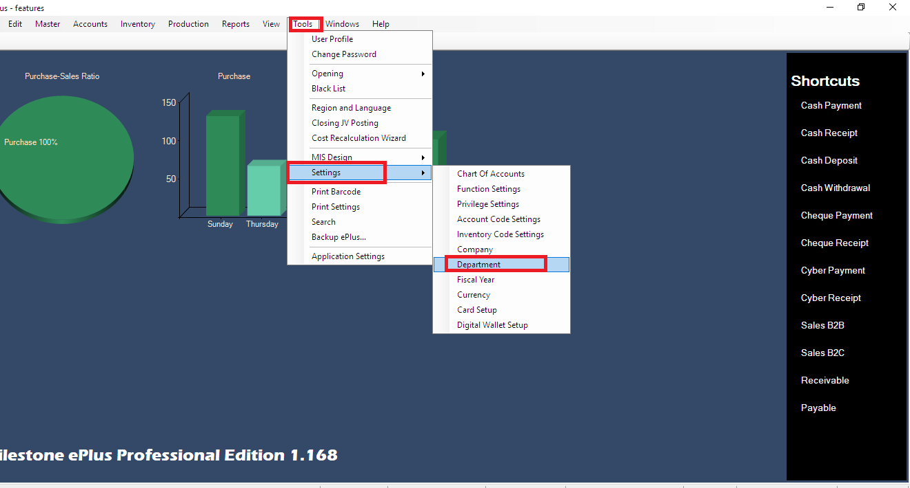

Create department->save

